Secure Product Catalog API
Implementation & Submission Documentation

1. Project Overview
The Secure Product Catalog API is a REST API built using Node.js, Express.js and TypeScript. The project implements API versioning, product CRUD routes, input validation and sanitization, security middleware, centralized error handling, and IP-based rate limiting.

2. Technologies Used
- Node.js
- Express.js
- TypeScript
- express-validator – request validation and sanitization
- express-rate-limit – rate limiting
- Helmet – HTTP security headers
- Postman – API testing
- Git and GitHub – version control and project submission

3. Project Setup
The project folder was created as:
secure-product-api
The required dependencies were installed for Express, validation, security and rate limiting. TypeScript development support was also configured.

4. Project Structure
secure-product-api/
├── middleware/
│ ├── errorHandler.ts
│ └── validate.ts
├── routes/
│ └── v1/
│ └── products.ts
├── app.ts
├── README.md
├── package.json
├── package-lock.json
├── Secure-product-api.postman_collection.json
└── tsconfig.json
The middleware folder contains validation and centralized error handling. The routes/v1 folder contains the versioned product routes. app.ts contains the main Express application configuration.

5. API Versioning
API versioning was implemented using the /api/v1/ prefix.
Base URL: http://localhost:4000/api/v1/products

6. Product API Routes
Method | Endpoint | Purpose | Expected Status
GET | /api/v1/products | Get all products | 200
GET | /api/v1/products/:id | Get product by ID | 200 / 404
POST | /api/v1/products | Create a product | 201 / 422
PUT | /api/v1/products/:id | Update a product | 200 / 404 / 422
DELETE | /api/v1/products/:id | Delete a product | 204 / 404

7. Product Validation Rules
- name – required and minimum 2 characters.
- price – required, must be numeric, and must be greater than 0.
- category – required.
- stock – required integer with minimum value 0.
- description – optional and maximum 500 characters.
Validation was implemented using express-validator. String fields are trimmed and escaped before processing. Invalid product input returns HTTP 422 with a JSON validation error response.

8. Security Measures
- Helmet is used to add security-related HTTP headers.
- JSON request bodies are limited to 10KB.
- URL-encoded request bodies are also limited to 10KB.
- Input strings are sanitized using trim() and escape().
- Rate limiting is applied to the product API.

9. Rate Limiting
The API uses express-rate-limit with a limit of 50 requests per 10 minutes per IP address.
windowMs: 10 * 60 * 1000
limit: 50
When the request limit is exceeded, the API returns HTTP 429 Too Many Requests with a JSON error response.

10. Centralized Error Handling
A centralized error handler was added in middleware/errorHandler.ts. It provides a consistent JSON response containing success, statusCode and message fields for application errors.

11. Running the API
The application was configured to run on port 4000.
http://localhost:4000/
The root endpoint was used to confirm that the API server was running successfully.

12. Postman Testing
Postman was used to test the API endpoints. The following tests were completed:
- GET all products – successful 200 response.
- GET product by ID – successful 200 response.
- POST product – successful 201 response.
- POST invalid product – validation error 422 response.
- PUT product – successful 200 response.
- PUT invalid product – validation error 422 response.
- DELETE product – successful 204 response.
- Rate-limit test – 429 Too Many Requests response.
A Postman collection was exported as:
Secure-product-api.postman_collection.json

13. Rate Limit Demonstration
To demonstrate the rate limit, multiple requests were sent to the product endpoint from a PowerShell terminal.
1..50 | ForEach-Object {
Invoke-WebRequest -Uri "http://localhost:4000/api/v1/products" -Method GET -UseBasicParsing | Out-Null
}
After the allowed request limit was reached, a subsequent request in Postman returned HTTP 429.

14. Git Configuration
Git was initialized inside the secure-product-api project.
git init
A .gitignore file was created to exclude unnecessary files:
node_modules/
dist/
.env
The project files were then staged and committed.
git add .
git commit -m "Initial commit - Secure Product Catalog API"

15. GitHub Repository
A public GitHub repository named secure-product-api was created and connected to the local repository.
https://github.com/pragathi-1252/secure-product-api
The local main branch was pushed successfully to GitHub using:
git push -u origin main

16. Screenshots to Add
The following screenshots can be inserted into this document as evidence of implementation and testing

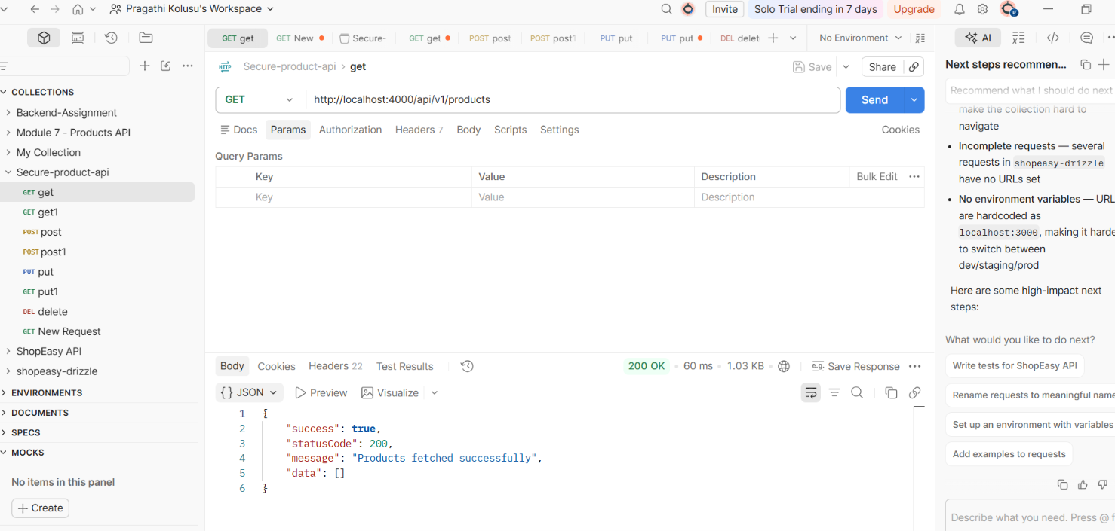

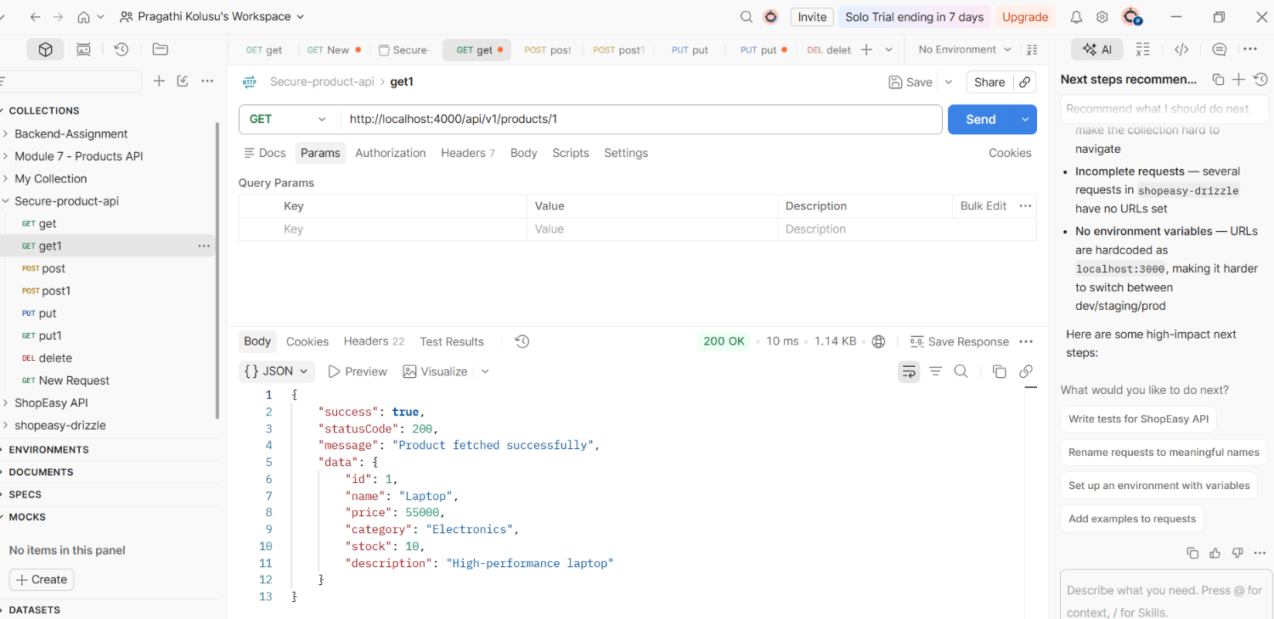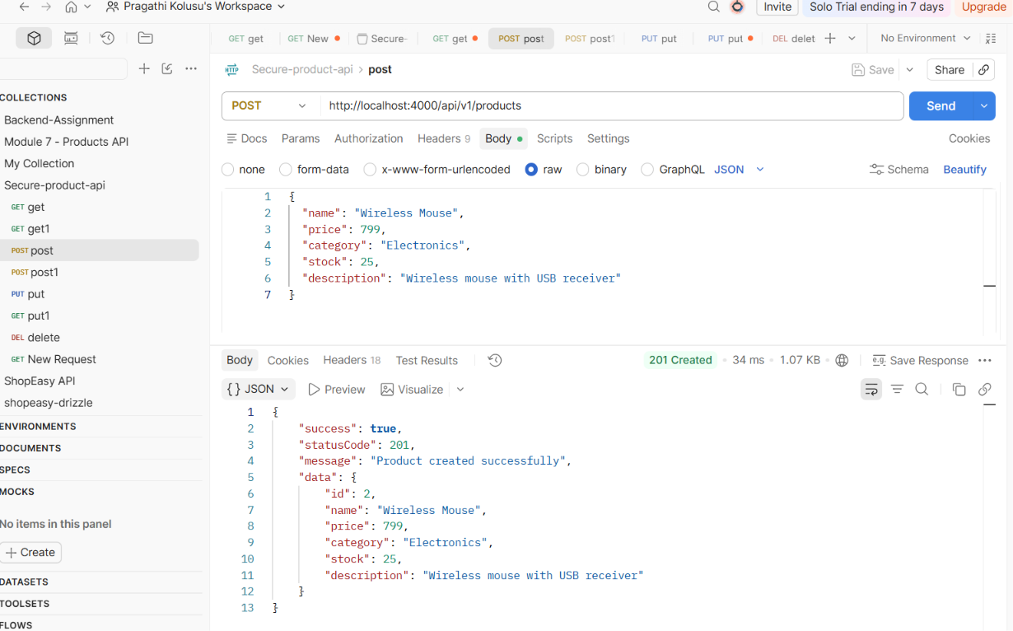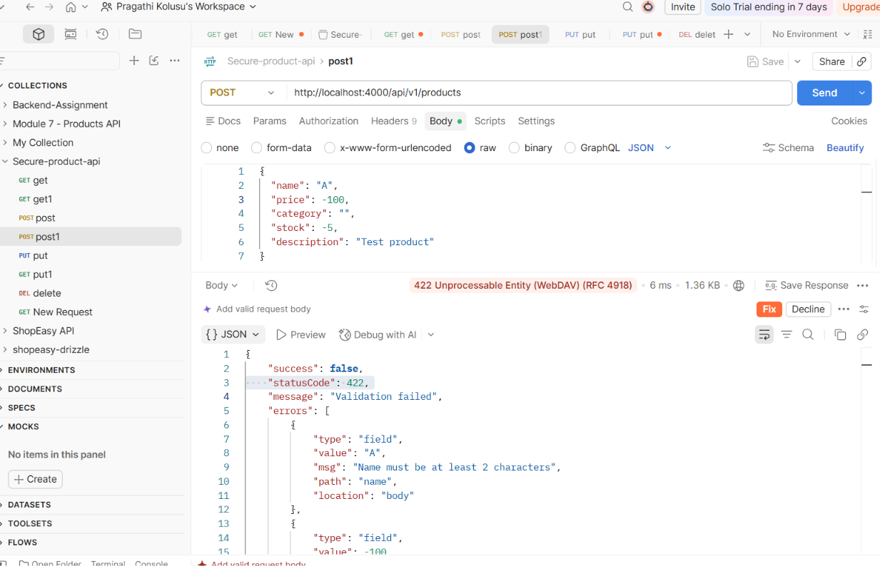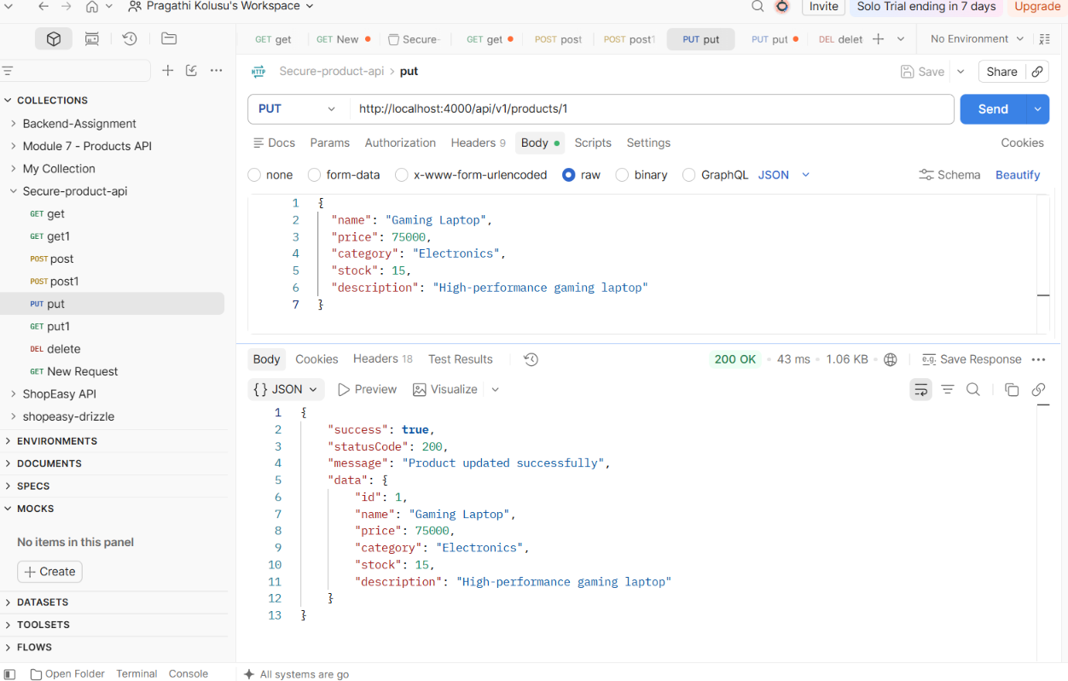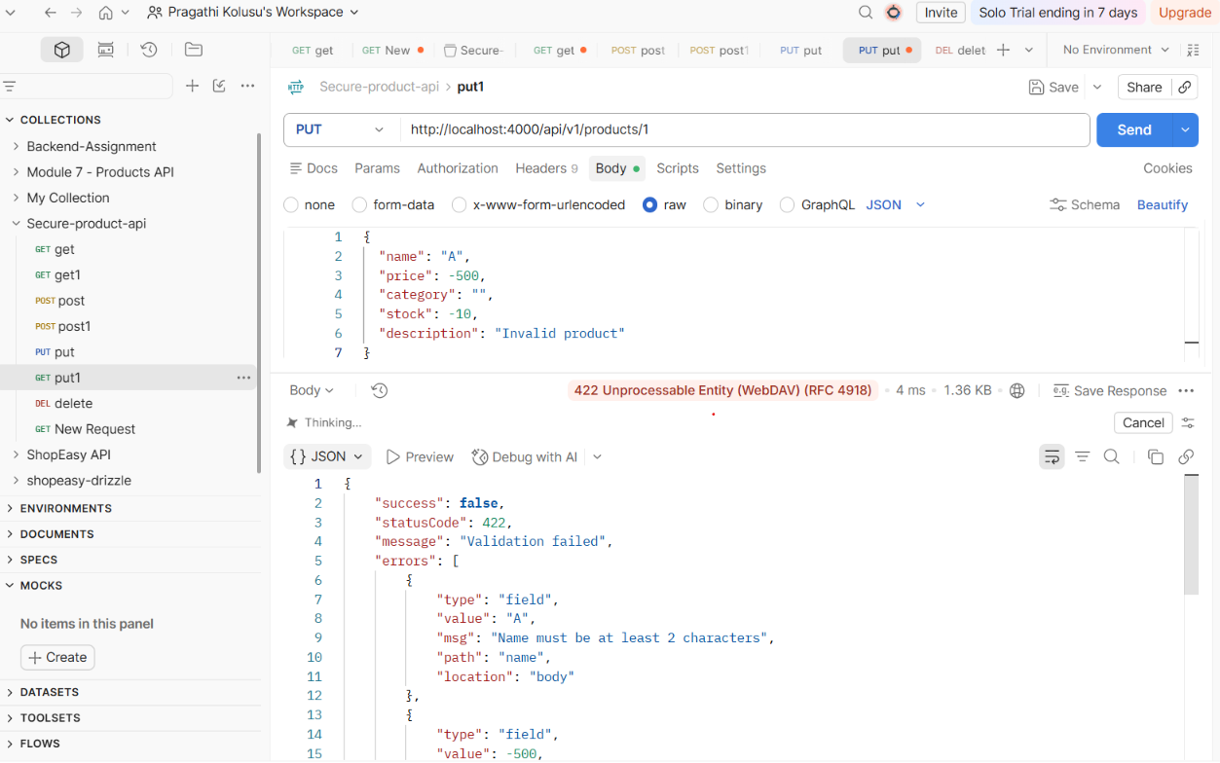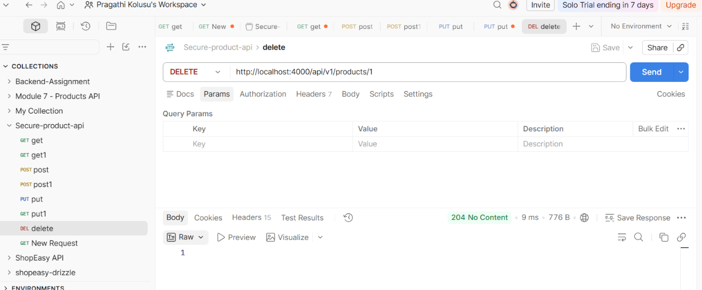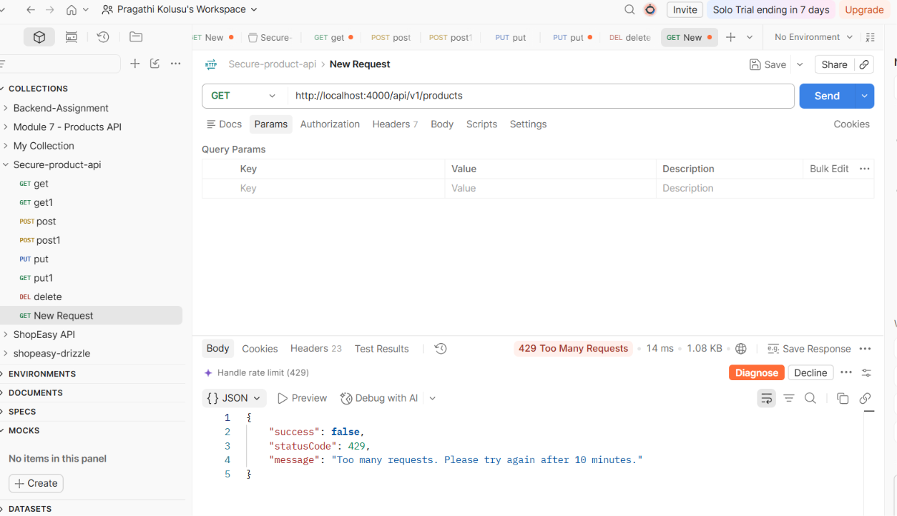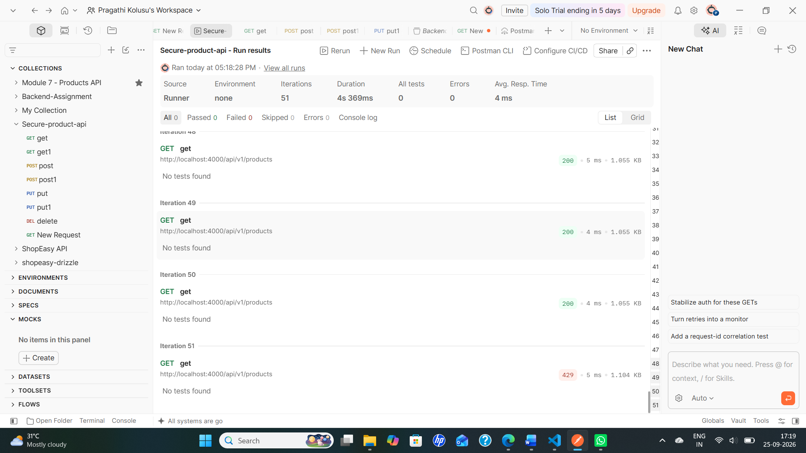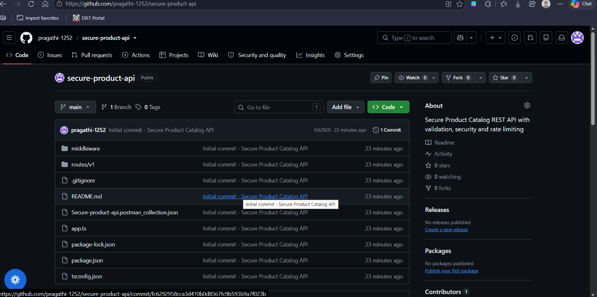

17. Final Checklist
☐ API versioning implemented.
☐ All five required product routes implemented.
☐ Validation and sanitization implemented.
☐ Correct HTTP status codes demonstrated.
☐ Centralized error handling implemented.
☐ Helmet security middleware enabled.
☐ 10KB request body limit configured.
☐ 50 requests per 10 minutes rate limit configured.
☐ 429 rate-limit response demonstrated.
☐ Postman collection exported.
☐ README added.
☐ Git repository initialized and committed.
☐ GitHub repository created and project pushed.
☐ Required screenshots collected and ready to insert.

18. Conclusion
The Secure Product Catalog API was implemented, tested with Postman, protected with basic security and rate-limiting measures, documented with a README, and uploaded to GitHub. The remaining submission step is to insert the collected screenshots into this document and submit the required GitHub link and Postman collection JSON.

